**Ideation Phase**

**Define the Problem Statements**

|  |  |
| --- | --- |
| Date | 19 September 2022 |
| Team ID | PNT2022DMID32660 |
| Project Name | Project -skill and job recommender |
| Maximum Marks | 2 Marks |

**Customer Problem Statement Template:**

Create a problem statement to understand your customer's point of view. The Customer Problem Statement template helps you focus on what matters to create experiences people will love.

A well-articulated customer problem statement allows you and your team to find the ideal solution for the challenges your customers face. Throughout the process, you’ll also be able to empathize with your customers, which helps you better understand how they perceive your product or service.

Reference: <https://miro.com/templates/customer-problem-statement/>

**Example:**

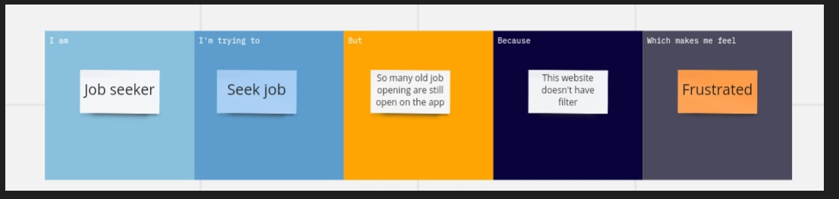

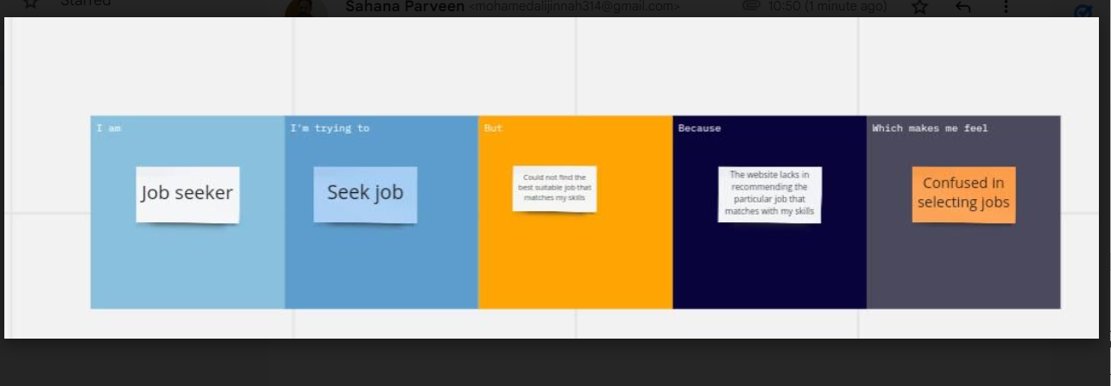

|  |  |  |  |  |  |
| --- | --- | --- | --- | --- | --- |
| **Problem Statement (PS)** | **I am (Customer)** | **I’m trying to** | **But** | **Because** | **Which makes me feel** |
| PS-1 | Job seeker | Seek job | So many old job are still open on the app | The website doesn’t have filter | frustrated |
| PS-2 | Job seeker | Seek job | Could not find the best job that matches my skills | The website could not recommend the particular jobs that maps with my skills | confused |